**UE Machine Learning: Supervised Techniques**

Exercise 2 Report

Name: Omar Amr

Matrikel-Nr: k11776960

**Marginal Distribution Visualization:**

P(x) is the density of a value x as input regardless of the target value. The following figure shows that the input density is maximum around the values x=-1 and x=3 (Approximately).

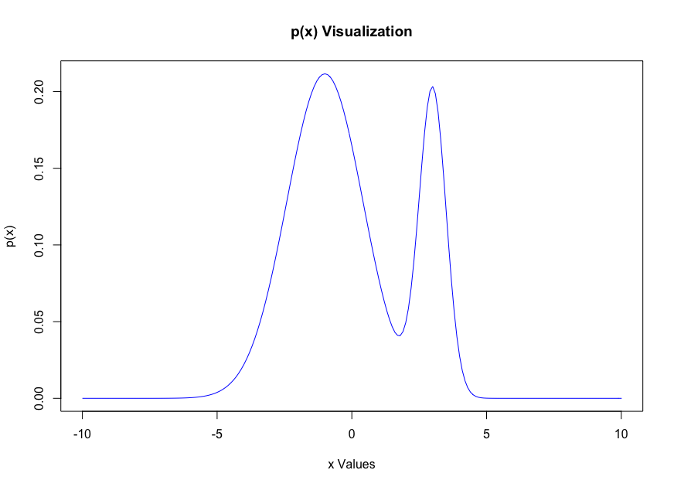

**Conditional Distribution Visualization:**

Conditional distribution is the density of input values for a specific target value. The graph below shows that for y=-1, the density of the input x is concentrated for the following intervals {x < 2 or x > 5}. On the other hand, the density for x where y=1 is concentrated in values between 2 and 5.

The graph below shows that input values that belong to the same class are close to each other. For example, most values between -10:2 and 5:10 belong to y=-1, and the other way around. This means that K-Nearest Neighbor Classification can be used here to classify a new input based on the majority of neighbors surrounding it.

**Illustration:**

An unknown input value x = 4 will be surrounded by other points between 2 and 5 that belong to the y=+1 class. Also, an input point x = -7 will have more close neighbors from the y=-1 class than y=+1 class, which means it will be classified as -1 class.

